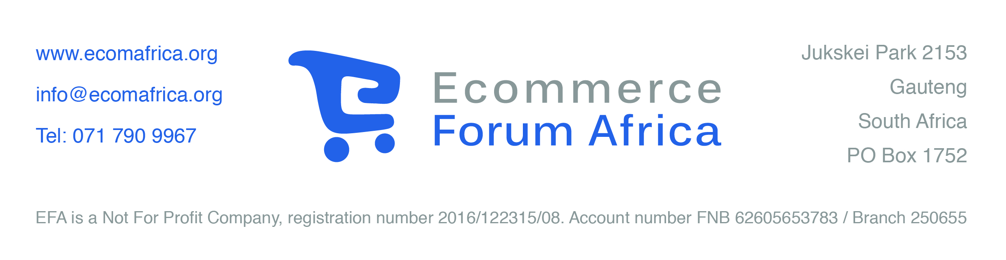

Comments on the Draft ICT SMME Support Strategy
by the Ecommerce Forum Africa

- Introduction
The Ecommerce Forum Africa (EFA) welcomes the opportunity to comment on the Department of Telecommunications and Postal Service’s (DTPS) Draft ICT SMME Support Strategy paper of 29 March 2017, and for the invitation to attend the national consultation on the E-Strategy, E-Government and ICT SMME Support Strategies on 8 and 9 May 2017.

The EFA was set up in November 2015 to provide a platform for the ecommerce sector. Its members represent all aspects of ecommerce – from emerchants (“etailers”), through payment gateways, logistics, specialized agencies, research, training and education, to website design.

Many SMMEs in the ICT sector use ecommerce to market their products to consumers, to businesses, or to government. A good example is the App Market, referred to on page 24 of the DTPS’s paper. Our comments herewith address the concerns of ICT SMMEs which use ecommerce, but are also true for ecommerce businesses in all sectors – from retail to tourism. Ecommerce in all its forms is, of course, dependent on the ICT sector, and needs a healthy, innovative and effective ICT infrastructure in order to flourish and grow.

Ecommerce is growing at a steady rate in the RSA. Ecommerce is not only the online sale of a product but also a marketing tool which gives the customer the information needed to make the best purchase in a store.

The internet is fundamentally changing the competitive relationship between SMMEs and large companies. This is part of the “Fourth Industrial Revolution”. Ecommerce plays a Key role in this change, allowing small companies to market their products to a far wider audience than previously, and, should the SMME wish, to reach global markets. The decision on how far to market products on line globally depends on payment systems, logistics (in the case of goods), and on taxes and import duties, and other restrictions. In this regard, we greatly welcome the DTPS as the champion of ecommerce in the RSA.

Ecommerce is made for SMMEs. In The Netherlands, for example, the number of emerchants grew from 5,195 in 2007 to 32,160 in 2016. Over 90% of these emerchants are classified as SMMEs. Given the right support from both national and regional government, small ecommerce shops could grow at similar rates here in the RSA.

- Challenges

As the consultation on 8-9 May pointed out, a number of major challenges face ICT SMMEs. As far as ecommerce is concerned these specifically include:
- The high cost of communications in the RSA, to which should also be added the fragility of internet and mobile communications. Not only is data costly, but also both copper and fibre optics (where that is available) and mobile communications often break down cutting off the SMME from its customers for hours, days or even longer. Sales are therefore lost or dropped to the detriment of the online seller.
- Legislative constraints: mostly these effect ecommerce because customs duties are unnecessarily complex making it costly to import necessary components or completed products, and also costly and lengthy to export to other African countries.
- Access to finance and lack of incentives to encourage SMMEs to develop and market their products. It is recognized that a high percentage of SMMEs fail in their first year. Some government funding is available, but this usually only covers the first year, leaving the crucial second and third year unfunded.
- Lack of appropriate skills and entrepreneurship. It is recognized that the education system fails to produce enough students conversant in maths, computer or business/entrepreneur skills. The new digital age depends on these skills and business has its place to play in encouraging these skills. Ecommerce has specific skills that need to be mastered by SMMEs which wish to sell online.
The EFA will comment further on this challenge below.

- Providing the necessary skills for ecommerce.

Ecommerce demands a unique set of skills. The ecommerce SMME requires an entrepreneur to start it up and the run it with a passion and consistency through both the ups and downs. As with any product, marketing and sales must be correctly focused, and the product competitively priced to attract the potential customer. The ecommerce entrepreneur must be able to apply the new digital marketing tools, such as analytics and search engine optimization in order to market effectively in the digital environment.

Once the sale commences and the online customer has clicked on the product he or she will expect to be able to pay online by a secure means, and then have the product either downloaded or provided in the case of services, or delivered to an address in the case of goods.

The ecommerce SMME must decide how to deal with online payments (for example does it use an EFT to a traditional bank, or a payment gateway?).

The SMME must also consider how to provide online customers with the services they have bought (for example how to present the download, or send through a ticket, and what terms and conditions, IP or other legal requirements apply).

If the customer has bought a physical product, how that can be warehoused and then delivered most effectively for the best price to the purchaser. The Consumer Protection Act requires that most consumer goods can be returned by the buyer if not wanted within a period of time (15 working days), and either the consumer is sent a replacement or refunded. This necessitates a system of “reverse logistics” to be in place.

Ecommerce therefore consists of a series of skill sets, which either the SMME must provide, or which can be found with expert service providers, many of which are themselves SMMEs specializing in specific aspects of ecommerce.

EFA intends to provide workshops to help guide existing and potential SMME and start-up entrepreneurs on their journey to use ecommerce. This will involve upskilling potential ecommerce employers and employees throughout the provinces, using trainers in at least 6 languages (and eventually all 11 languages if the project succeeds).

The EFA believes that the potential for start-up ecommerce businesses throughout the RSA, in all the provinces and in rural areas is great, is untapped, and is crying out for development. Introductory training for SMMEs and start-up is in line with the government’s policies of transformation and empowerment. We therefore ask the DTPS and the other related ministries to lend their support so that we can find the necessary funding to provide this training by means of sponsorship.

------------------------------------

June 2017

